**Background Information**

Adolescent and youth programs has been implemented since year 2016 in four counties- Vihiga, Kisumu, Siaya and Homa Bay. The program focuses in advocacy for age appropriate Sexual Reproductive Health and Rights (SRHR), life skill education, peer based multi-media education and facilitating referral and linkage, reaching 22 ,480 schoolbased approach and 12,890 community based approaches. The overall objective of the program is to improve the SRHR of young people, and girls aged 10-24 by increasing their access to comprehensive SRHR information and services, advocacy initiatives around Comprehensive sexuality education, youth friendly services and fight against harmful cultural practices, collaborative and partnership efforts of county and national government, achievement increased utilization of comprehensive SRHR information and education by all young people, increased utilization of quality and youth-friendly SRHR services that respond to the needs and rights of all young people, and improved social-cultural, political and legal environment for gender-sensitive, youth-friendly SRHR.

**PHOTOS GALLERY**

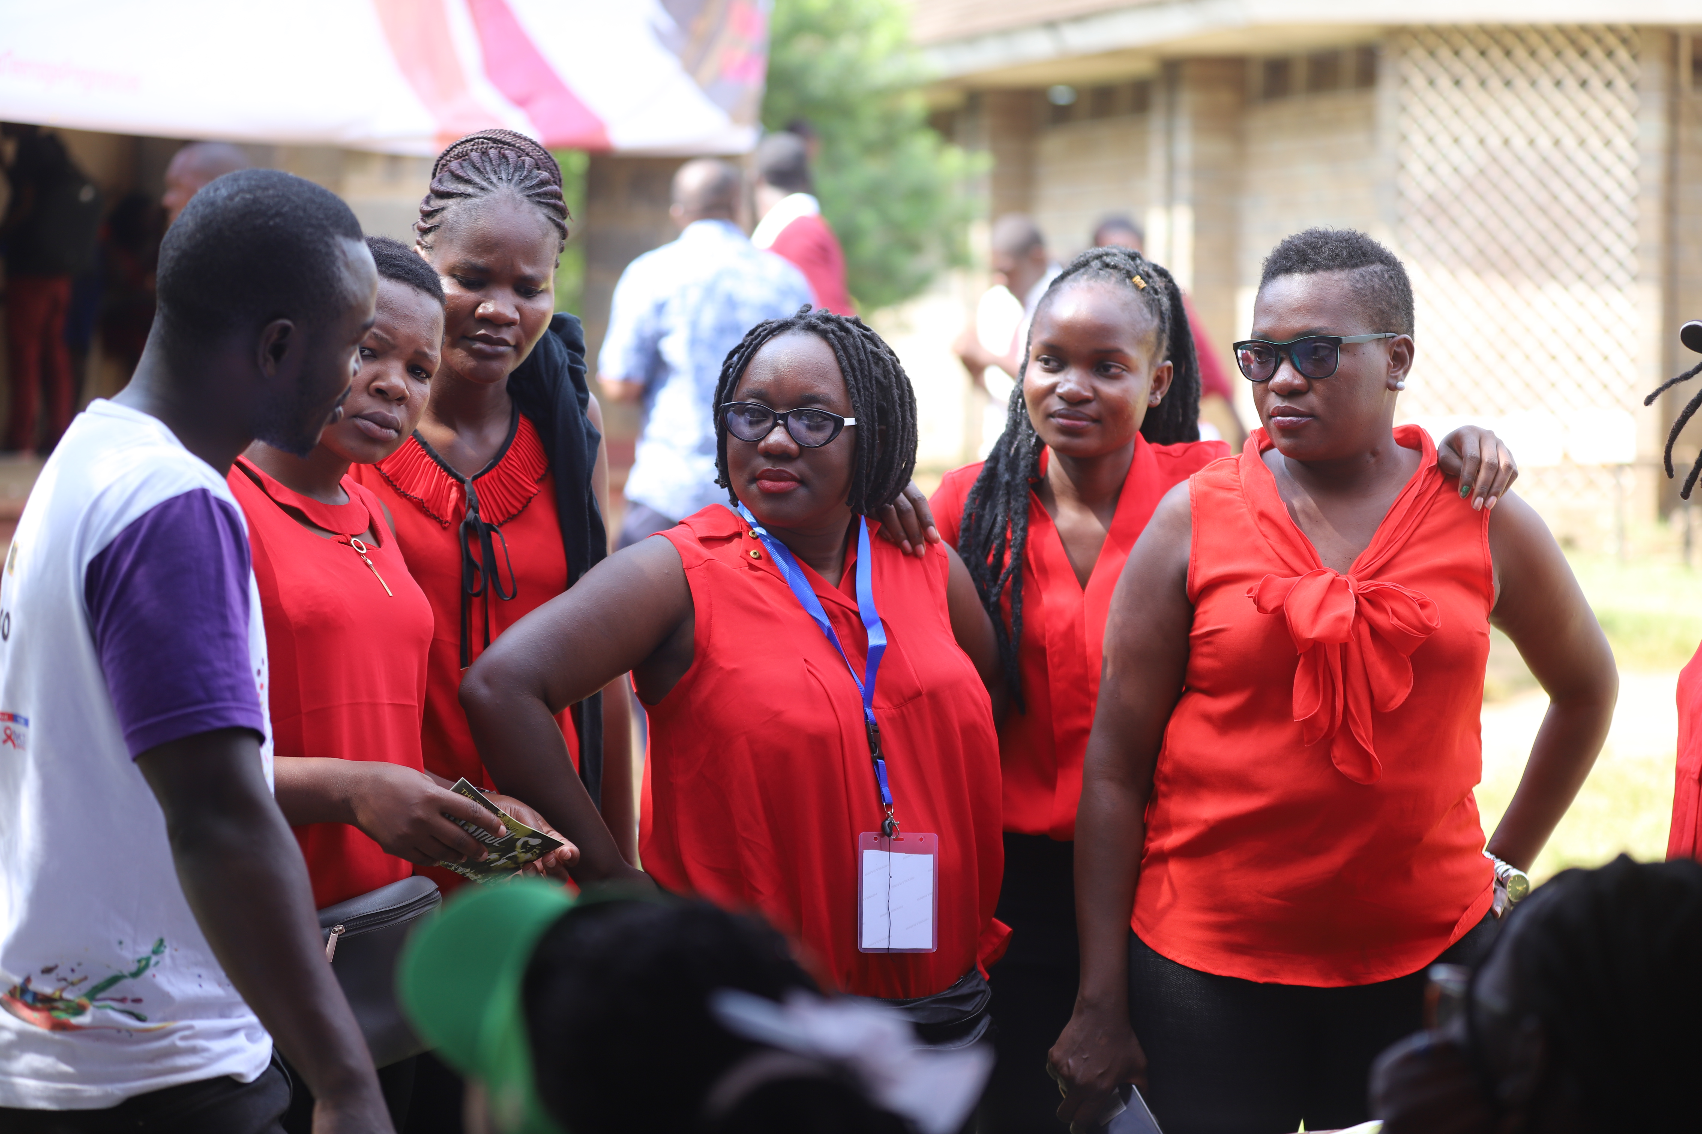

STIPA staff during adolescent open day

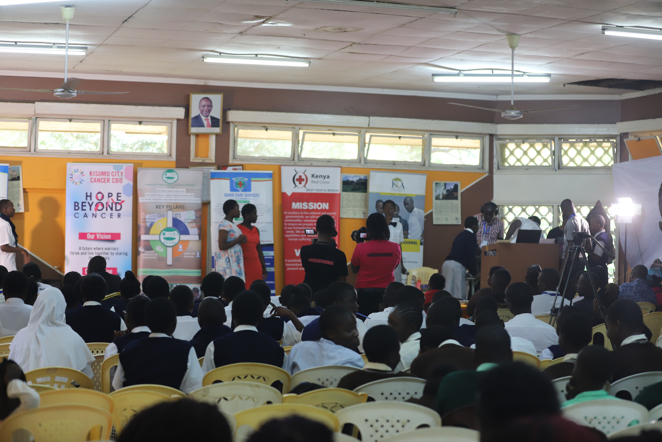

Health Conversation during adolescent open day

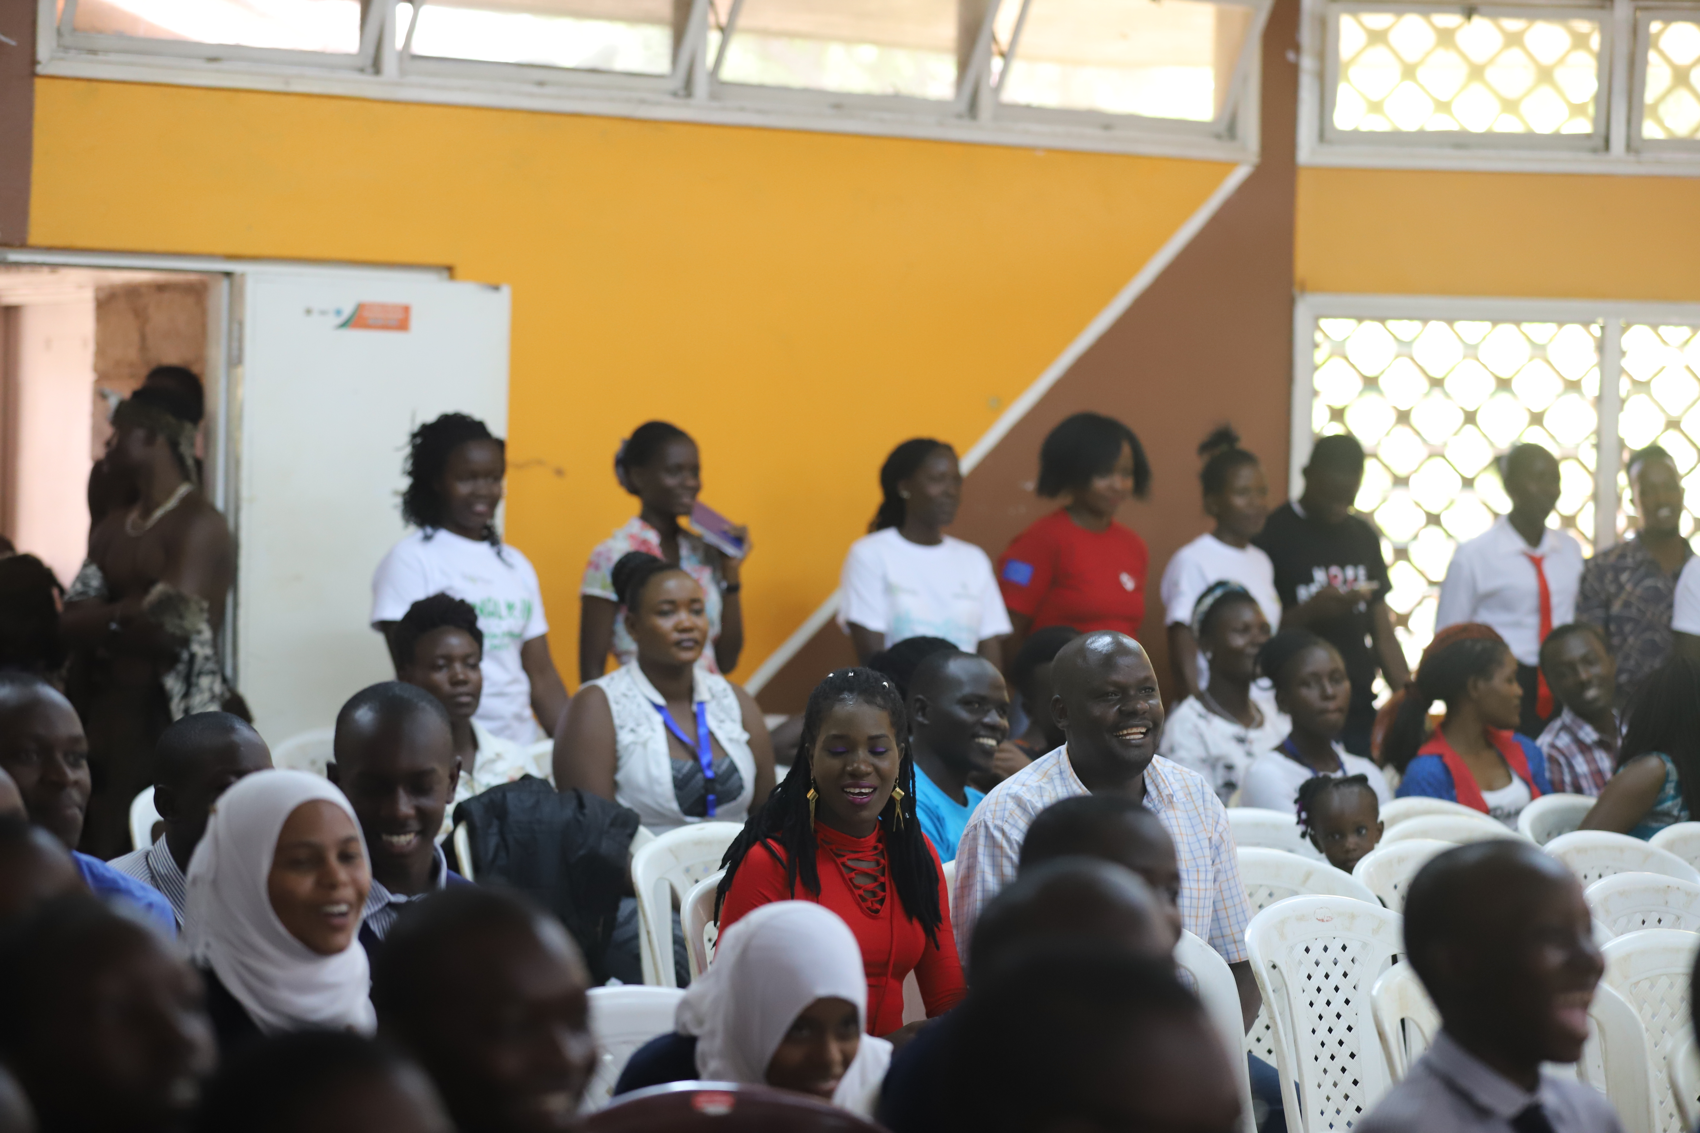

Lively sessions during adolescent open day

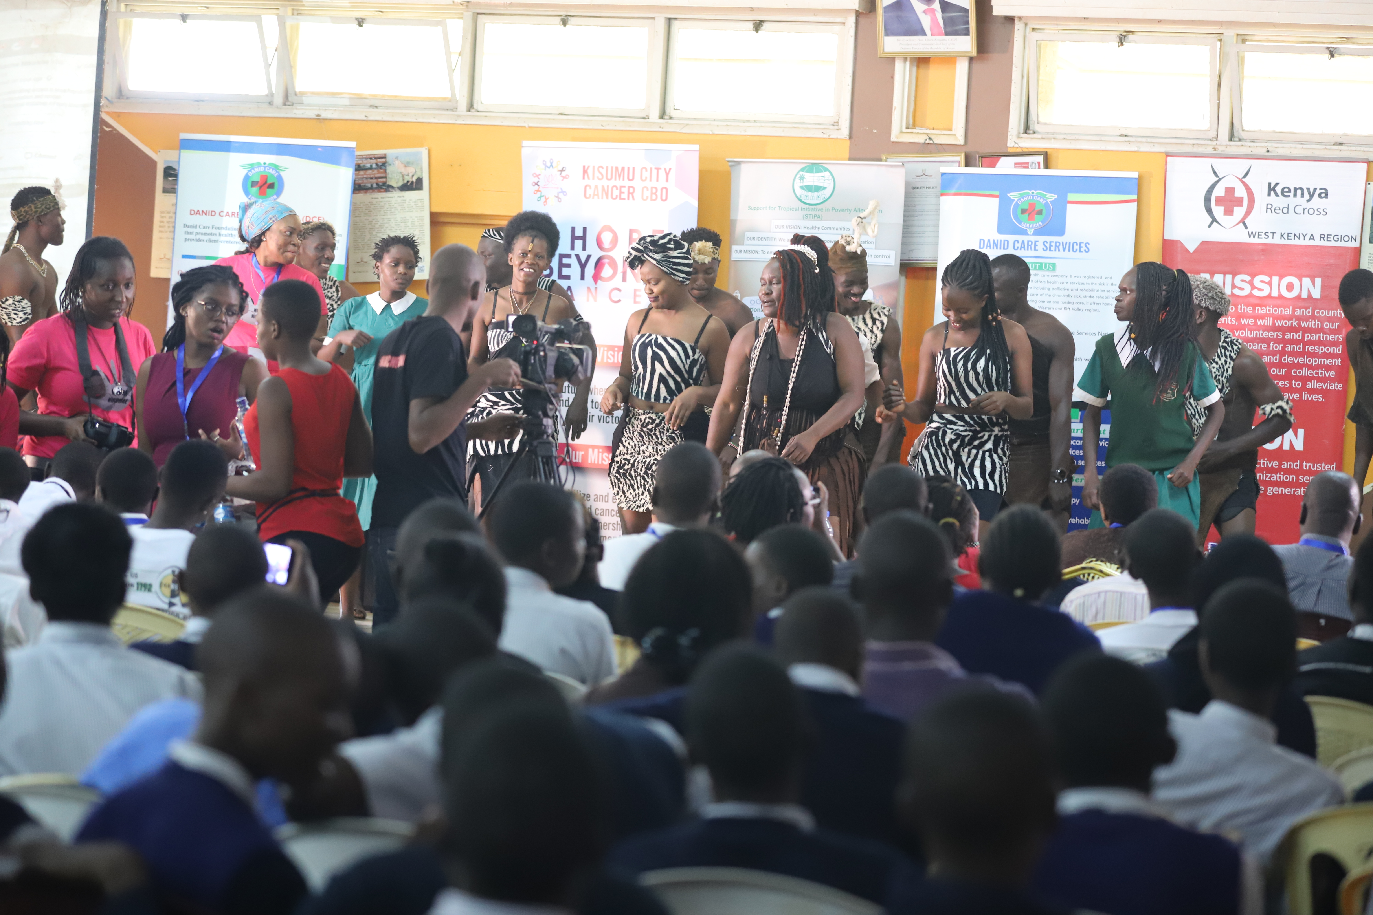

Edutainment session during adolescent open day